1/26/2018

Dominic Goodman, Christopher Woodard, Zac Henderson

Group 7

User Guide

Personal Task Manager

Table of Contents

Revision History 3

Introduction 4

Purpose 4

Scope 4

Overview of User Interface 5

What are the Key Features 5

How do I Navigate the User Interface? 5

Where to Start 6

How to Download the Personal Task Manager (PTM) 6

How to Install the Personal Task Manager (PTM) 6

How to Launch the Personal Task Manager (PTM) 6

Where to go from here 6

Tasks 7

How to Create a Task 7

How to Add Multiple Tasks from a File 9

How to Delete a Task 9

How to Edit a Task 9

How to Associate a Timer with a Task 9

Groups 10

How to Create a Group 10

How to Edit a Group 10

How to Delete a Group 10

How to Add a Task to a Group 10

How to Remove a Task from a Group 10

Saving a Task List using an Input File 11

What Format to Use with Task File 11

How to Input Data into a Task File 12

How to Save a Task File 12

Using the Calendar View 13

How to Interact with the Calendar 13

How to Select a Task in the Calendar 13

How to Manipulate Tasks in the Calendar 13

How to Move a Task in the Calendar 13

How to Add a Task to the Calendar 13

How to Edit a Task from the Calendar 13

How to Delete a Task from the Calendar 13

How to Change the System Settings 14

How to Set a Default Save Location 14

How to Set Email Notifications 14

How to Use the Application 15

General Usage Overview 15

How to Read Tasks Currently in the Application 15

How to Access Help Section 15

How to Exit the Application 15

# Revision History



# Introduction

## Purpose

The purpose of this document is to provide a detailed guide to users interacting with the PTM application. This document is split into numerous categorized sections.

## Scope

The purpose of this project is to act as a GUI (Graphical User Interface) based .net application that facilitates the input, storage, and processing of user defined tasks. The GUI will allow for displaying, editing, and interacting with tasks through a daily, weekly, and monthly graphical display.

The tasks will be ordered and displayed in a queue that the user can manipulate through reordering of tasks. The user will have the ability to manipulate the information associated with each task through interaction with the GUI. This interaction will provide an increased level of control on a granular level.

Goals and/or achievements will be associated with groups of tasks and time frames. Users will be able to plan out specific groupings of tasks for the goals and then receive information on the specific and overall progress toward the goals. Notifications on completion of tasks & goals will help quickly inform the user.

Furthermore, the software needs to reduce the complexity of keeping track of various tasks. A Database will be utilized in the storage of the task information. The application will interact with the database to store, track, and process task information.

# Overview of User Interface

## What are the Key Features

* Ability to add tasks
* Set Timers on tasks
* Have notifications on tasks
* Reorganize Tasks as desired
* View your tasks in a list, daily view, weekly view, and monthly calendar view.
* Load bulk tasks from a CSV, Text file or Task file
* Associate descriptions with each task for later review
* Save task lists
* Associate tasks with user defined Groups
* View Daily Tasks and Total tasks available
* Easily useable GUI

## How do I Navigate the User Interface?

The user interface focuses are four tabs. The Dashboard which allows the user to see a list of tasks, create new tasks and groups, and edit tasks. The Daily view is an organized list of the tasks for the day. The Weekly view is a list of the tasks for the week. The Monthly view is a calendar view of the tasks available for the month.

# Where to Start

## How to Download the Personal Task Manager (PTM)

Make your selection between the win32 and win 64 version of the application. Click the download link at “Insert Link Here” and allow the executable to download. Open the file location where you choose to download the application.

## How to Install the Personal Task Manager (PTM)

There is no installation process required to run the application.

## How to Launch the Personal Task Manager (PTM)

Once in the install directory double click the PersonaltaskManager.exe icon. This will launch the application and bring you to the dashboard.

## Where to go from here

The remainder of the User Guide describes in detail various portions of the application and how a user should interact with them. If you need additional assistance with using PTM please refer to the sections where you need guidance. The document is full of step by step information with pictures depicting the processes. You can read straight through the document or jump to the sections desired.

# Tasks

## How to Create a Task

To create a task, you need to

1. Navigate to the dashboard.
2. From the Dashboard Tab Click the Create Task button near the bottom of the application.

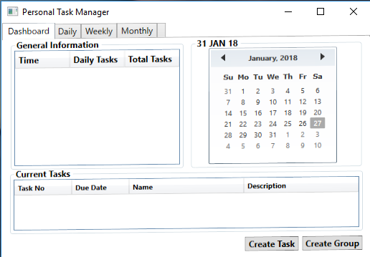

*Figure. 1 – Personal Task Manager Dashboard*

After clicking the Create Task button the Create Task Window will open.

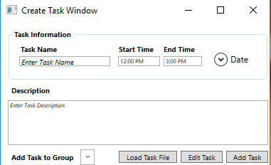

*Figure. 2 – Create Task Window*

1. From the Create Task Window enter a Task Name.
2. If you desire a start and stopping time to be associated with the task then add a time in the format XX:XX AM/PM (Ex. 12:01 PM).
3. Select a date to associate with the task from the dropdown Calendar.
4. Provide a description of the task in the description text area.
5. You can then add this task to a Group if you have one created which is done by clicking the drop down next to Add Task to Group.
6. Finally click Add Task

## How to Add Multiple Tasks from a File

1. Navigate to the Dashboard and click the Create Task button.
2. After the Create Task window opens click the Load Task File
3. This will open a directory window to select the file which should be a delimited csv, text, or task files.
4. After you select the file it will be read in and all the tasks displayed in a list.
5. Next to each list there is a checkbox you click if you want to keep the task or remove the task.
6. Finally click add tasks.

## How to Delete a Task

1. Select a task from the dashboard, daily view, weekly view, or monthly view and select the delete button.
2. This will prompt whether you want to remove the task.
3. Click delete and the task will be removed from the list.

## How to Edit a Task

1. Select a task from the dashboard, daily view, weekly view, or monthly view and select the edit button.
2. This will open the Edit Task Window.
3. Edit the desired values in the task window.
4. Finally click Save Changes.

## How to Associate a Timer with a Task

1. Navigate to the Dashboard and click the Create Task button.
2. After the Create Task window opens you can add a timer to a new task
3. Alternatively, you can edit the task timer in the Edit Task Window

# Groups

## How to Create a Group

Under Development

## How to Edit a Group

Under Development

## How to Delete a Group

Under Development

## How to Add a Task to a Group

Under Development

## How to Remove a Task from a Group

Under Development

# Saving a Task List using an Input File

## What Format to Use with Task File

A task file is simple to format and is mostly up to the user how you wish to define it. Though there are at least 2 tags needed within each task file, those being the “Fields” tag and the “End of line character” tag both of which must be defined on a line with a # at the start. An example of one is shown below

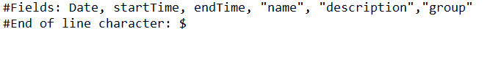

Each tag is to be specified in a certain way,

For the “fields” tag it may be a comma separated list of values that are taken from the table below.

|  |  |  |  |
| --- | --- | --- | --- |
| Field | Values accepted | Examples | If missing |
| Date | YYYY/MM/DD | 2018/01/27 | Required |
| startTime | 24-hour time | 1200  0600  300 | The task will be set to all day, defaults to 0000 hours of the day |
| endTime | The task will remain active until marked done. |
| “name” | A sentence or word that is contained within quotation marks | “Sample task”  “Sample”  “Long sentence of an example” | The task will have no name, recommended to be present. |
| “description” | The task will not have any description when viewed in the UI. |
| “group” | The task will be allocated to the general group. |

For the “End of line character” tag a single character must be noted that will be present at the end of each task, it is required that the character is not alphanumeric but rather a special symbol such as a $ or a %.

## How to Input Data into a Task File

The format of creating a task depends on how you defined the “fields” tag in the previous section, for this example I will be using the format **Date, startTime, endTime, "name", "description","group"**. This can be done within any text editor.

1. Create the basic format of the task file, the previous step shows how to do this.
2. On the first blank line after the tags being with inputting the first value for the first field shown in the fields tag, for this example it will be Date. Upon putting the date follow the field with a ‘,’.
3. Repeat the previous step for each field until the last field is placed.
4. After placing the last field place a single character of what is specified for the “End of line character” tag, for this example we will use a ‘$’ symbol.
5. Continue to the next black line and repeat these steps for each line until all of the tasks you want to add are present.

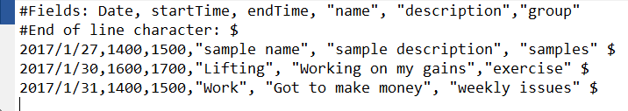

## How to Save a Task File

You are able to save the file as either a .txt file or a .task, either of which will be compatible to be opened within the application.

# Using the Calendar View

## How to Interact with the Calendar

Under Development

## How to Select a Task in the Calendar

Under Development

## How to Manipulate Tasks in the Calendar

Under Development

## How to Move a Task in the Calendar

Under Development

## How to Add a Task to the Calendar

Under Development

## How to Edit a Task from the Calendar

Under Development

## How to Delete a Task from the Calendar

Under Development

# How to Change the System Settings

## How to Set a Default Save Location

1. Navigate to the Settings tab
2. From the settings tab change the value present in the text field titled Save Location.
3. You can do this by clicking the browse button and selecting a save location or typing in a directory path.

## How to Set Email Notifications

1. Navigate to the Settings tab
2. From the settings tab change the value present in the text field titled default Email.
3. You can do this by typing in a new email in the text box title Email and then click save.

# How to Use the Application

## General Usage Overview

The application is intended to be used daily. You first launch the application and add in the desired tasks. You can then organize the tasks to fit you needs. You can monitor your task list from various views and make alterations as needed. The application will save your current tasks and load them in on launching of the application.

## How to Read Tasks Currently in the Application

Each task has a variety of details available to review. A task can have all or many of these options

* Name – Name of task
* Description – Gives a description of the task
* Start Time – The time the task should begin
* Ending Time – The time a task should be considered past the deadline.
* Group – a group has 1 or many tasks associated with it.
* Date – the day the task should be due.

## How to Access Help Section

You can access the help section from the menu. Click the help dropdown from the menu. This will open the help section.

## How to Exit the Application

Click the X in the top right corner of the screen. This will close the application.